Quarterly Report Guidelines and Data Reports
For MIS to display the correct quarter dates on reports, you must update the contract dates yearly. To do so,
- Click on Settings
- Click on Program Information Form
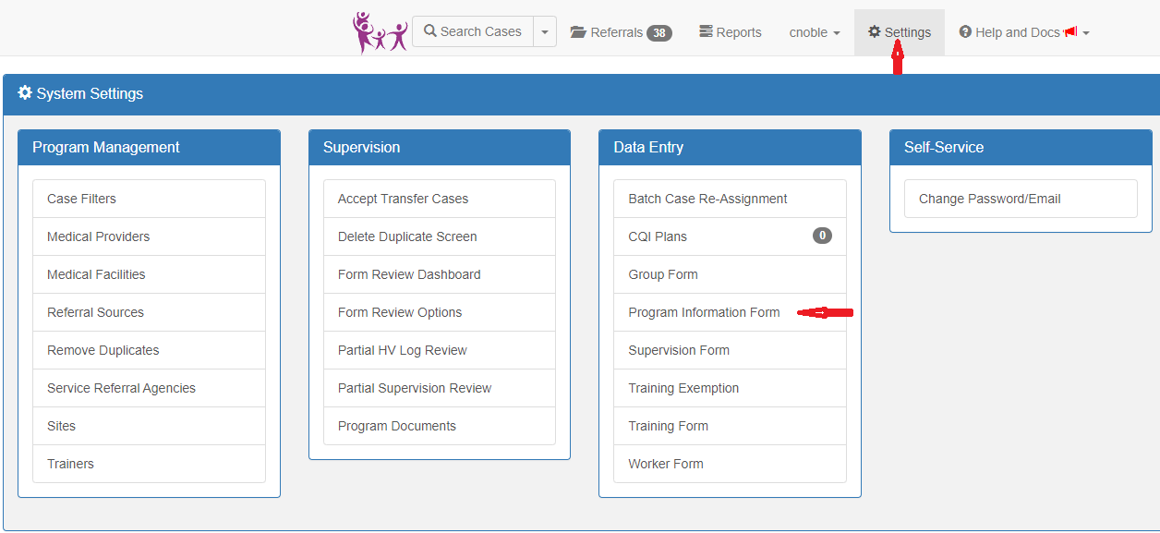

- Click on Contract tab.
- Enter Contract Start and End date.
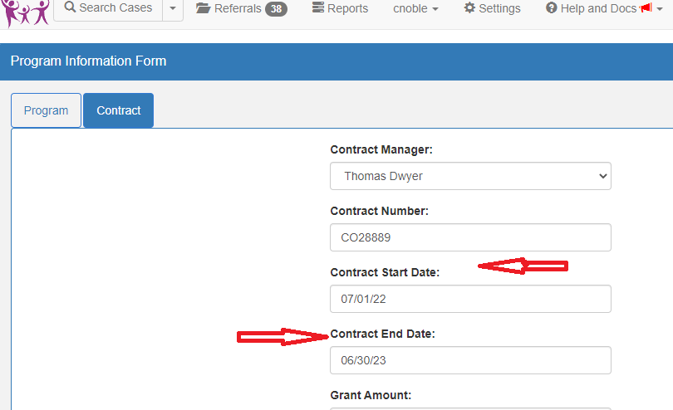

Quarterly Report Guidelines and Data Reports
Your quarterly report will include the following MIS reports:
Report Title | Report Catalog tab | Pages to include | √= data received  Χ= data not submitted
Home Visit Log Summary | Quarterlies | All
4-2.B HFA Home Visiting Completion Rate Analysis- Summary | Accreditation | All
Performance Targets for 4 Quarters | Quarterlies | All
1-1.C Referral Source Outcome Summary Report | Accreditation | All
1-2.B Initial Engagement Process Report | Accreditation | First Page
1-4.A and B Acceptance Rate and Analysis (One-Step). Use default dates, If the start date is prior to 11/15/2022 you will need to run the two-step report up until 11/14/2022. Run the one step with a start date of 11/15/2022. Please review SLM Annual Service Review-Acceptance and Retention Analyses presentation on HFNY website for more details. | Accreditation | All
Capacity Building (One-Step) | Analysis | All
12-1.B Regularly scheduled and Protected Supervision – Summary (Site Option) | Accreditation | All

Tips for pulling reports from MIS:
- Utilizing the search tool and/or filters ribbon on the report catalog page can help the user navigate to the correct report swiftly. For example, if you wanted to run the Home Visit Log Summary:
  - Once you’ve clicked on the Reports tab, click on the Quarterlies tab (located in the filters ribbon at the top). Notice how it the number of reports shown went down!
  - Scroll down until you find the Home Visit Log Summary
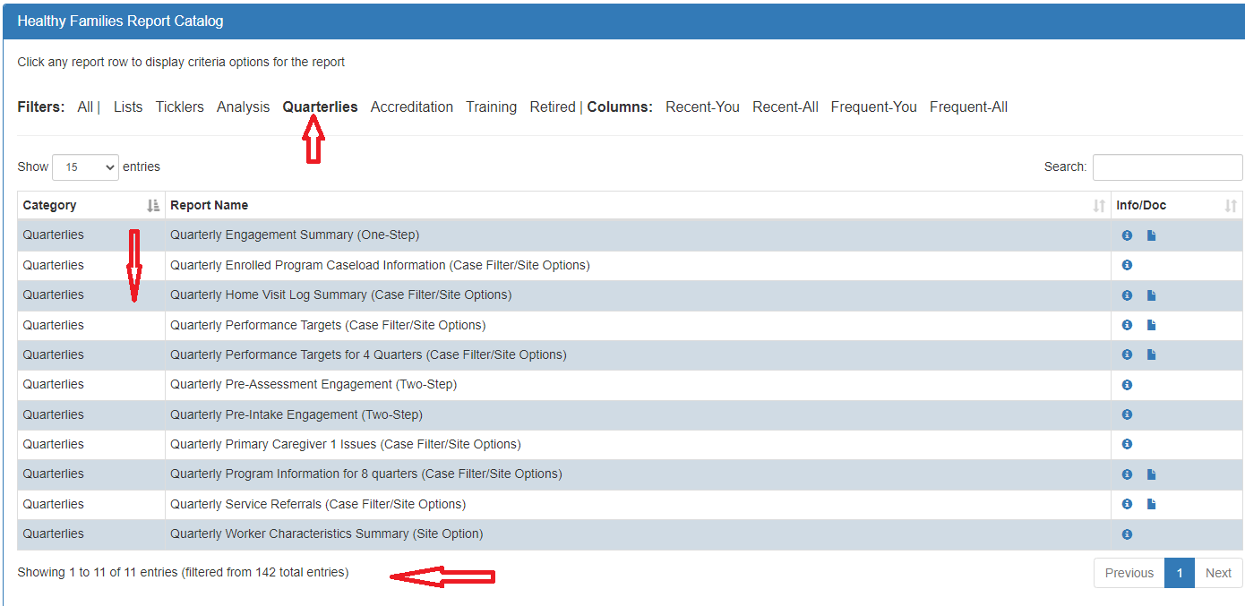

Quarterly Report Guidelines and Data Reports

- 2. The user can also utilize the search option (located on the top right-hand corner of reports page). It’s recommended that the user first click on the All tab in the filters ribbon and then type key word(s) in search box to locate desired report.
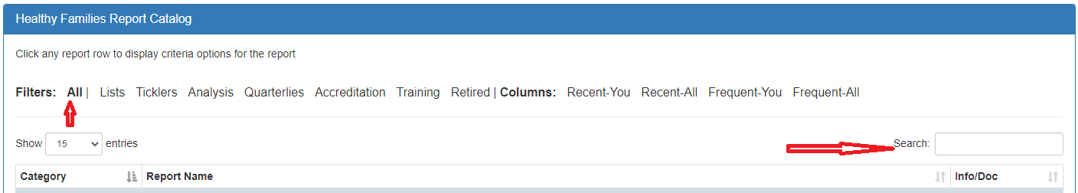

Tips/Reminders for completing quarterly report narratives:
- Referencing the quarterly report data checklist and running the reports listed will help to complete quarterly reports.
- Please include narrative based on your review/analysis of Length of Time Between Key Pre-Enrollment Dates and Home Visit Log Summarry from MIS.
- To Determine the number of father figures that participated in FROGS and home visits for the quarter, refer to the Aggregate Counts Report. Enter the start and end date accordinlgy and run report. The information can be found uner the FROG and Home Visits section of the report.
- For more detailed information on uploading documents into CMS please refer to the “Uploading Claim Documents”section of the CMS Manual located on the OCFS website.

